CHAPTER NO 16

MICROSOFT EXCEL 2007

Microsoft Excel 2007 is an electronic spreadsheet software package that allows you to organize data in a tabular format, perform mathematical calculations, and analyze data. This software includes functions, formulas, and charts. It is commonly used in business, engineering, mathematics, and statistics.

Microsoft Excel 2007 is the newest version of Microsoft Office's worksheet (spreadsheet) program. Technically a worksheet is a single document inside a workbook but we often use the terms worksheet, spreadsheet and workbook interchangeably. Worksheets contain numerical information presented in tabular row and column format with text that labels the data.
It can also contain graphics and charts. Like Microsoft Word 2007, Excel 2007 takes advantage of a new, results-oriented user interface to make powerful productivity tools easily accessible. If you're worried about capacity, Excel 2007 now accommodates 1 million rows and 16,000 columns.
GETTING START

To start MS Excel click on the Start Menu on the bottom left corner of your desktop and select Start→ All Programs→ Microsoft Office →Microsoft Office excel 2007.

SCREEN LAYOUT

The MS Excel 2007 interface brings out all the functionality of the software using tabs rather than drop-down menus.

The main work area is called a spreadsheet where you can communicate your data using functions, formulas, and charts.

The highlighted cell is called the active cell and is the current place where you can enter a value or a formula. We will describe the parts of the interface in the following sections.

Getting started with Excel 2007 will notice that there are many features. There are three features that you should remember as you work within Excel 2007:
- The Microsoft Office Button,
- The Quick Access Toolbar,
- The Ribbon.
The function of these features will be more fully explored below.
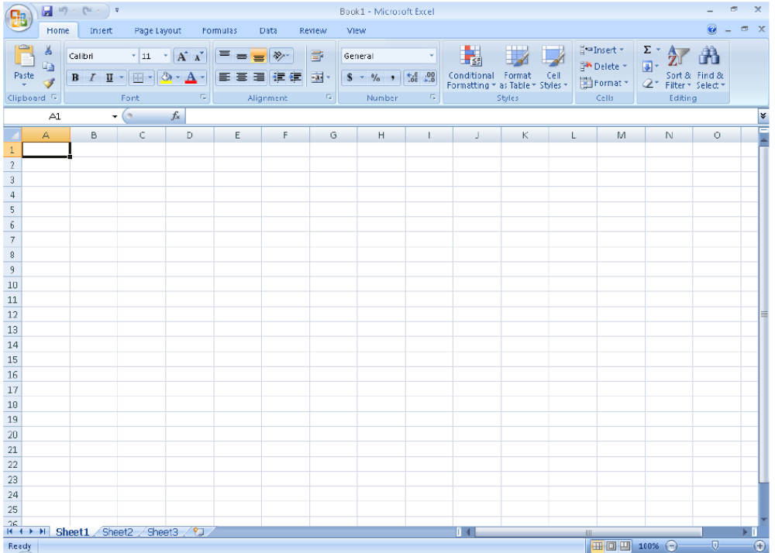

OFFICE BUTTON

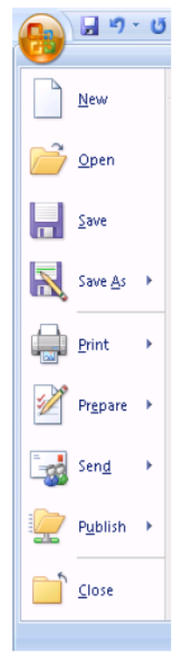
The Office button (located at the top left of the MS Excel Window) is a drop-down menu of commands that you can use on MS Excel files. It includes creating a new file, opening an existing file, saving, and printing. A menu choice with a right pointing arrow expands to another menu of command choices.



RIBBON
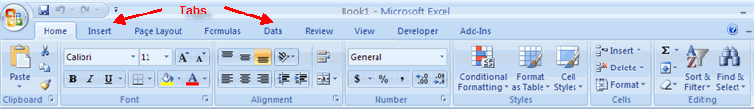
The ribbon is the panel at the top portion of the document It has seven tabs: Home, Insert, Page Layouts, Formulas, Data, Review, and View. Each tab is divided into groups. The groups are logical collections of features designed to perform function that you will utilize in developing or editing your Excel spreadsheets.

Commonly utilized features are displayed on the Ribbon. To view additional features within each group, click the arrow at the bottom right corner of each group.
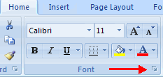

HOME: | Clipboard, Fonts, Alignment, Number, Styles, Cells, Editing.
INSERT: | Tables, Illustrations, Links, Text, and Media Clips.
PAGE LAYOUTS: | Themes, Page Setup, Scale to Fit, Sheet Options, Arrange
FORMULAS: | Function Library, Defined Names, Formula Auditing, Calculation
DATA: | Start Slide Show, Set Up, Monitors.
REVIEW | Proofing, Comments, Protect.
VIEW: | Presentation Views, Show/Hide, Zoom, Window, Macros

QUICK ACCESS TOOLBAR
The Quick Access Toolbar is a customizable toolbar that contains commands that you may want to use. You can place the quick access toolbar above or below the ribbon. To change the location of the quick access toolbar, click on the arrow at the end of the toolbar and click Show below the Ribbon.
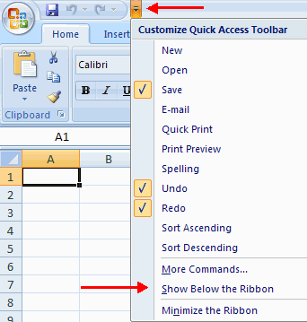

MINI TOOLBAR
A new feature in Office 2007 is the Mini Toolbar. This is a floating toolbar that is displayed when you select text or right-click text. It displays common formatting tools, such as Bold, Italics, Fonts, Font Size and Font Color.
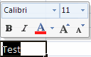

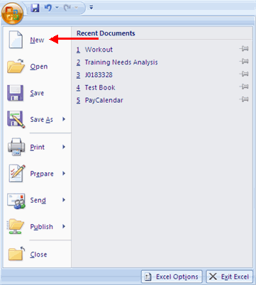
HOW TO CREATE A WORKBOOK
To create a new Workbook:
- Click the Microsoft Office Toolbar
- Click New
- Choose Blank Document

If you want to create a new document from a template, explore the templates and choose one that fits your needs.
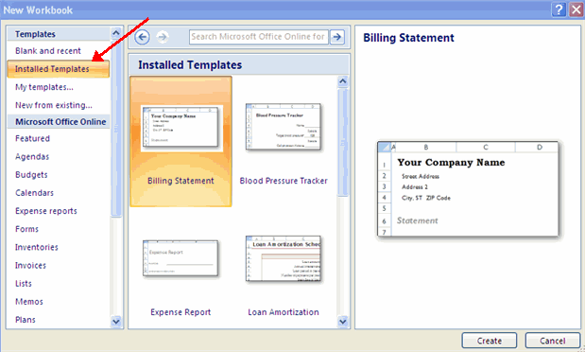

SAVE A WORKBOOK
When you save a workbook, you have two choices: Save or Save As.
To save a document:
- Click the Microsoft Office Button
- Click Save
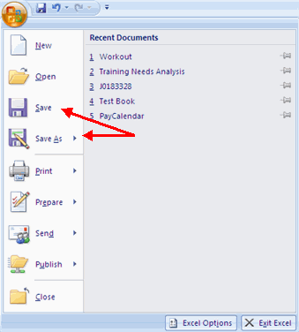

You may need to use the Save As feature when you need to save a workbook under a different name or to save it for earlier versions of Excel. Remember that older versions of Excel will not be able to open an Excel 2007 worksheet unless you save it as an Excel 97-2003 Format. To use the Save As feature:
- Click the Microsoft Office Button
- Click Save As
- Type in the name for the Workbook
- In the Save as Type box, choose Excel 97-2003 Workbook
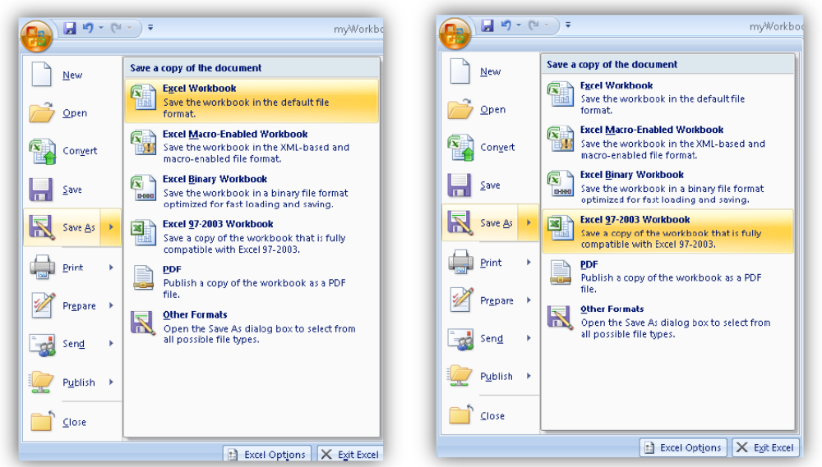
OPEN A WORKBOOK
To open an existing workbook:
- Click the Microsoft Office Button
- Click Open
- Browse to the workbook
- Click the title of the workbook
- Click Open
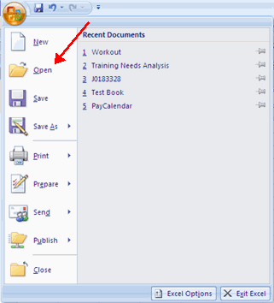

ENTERING DATA
There are different ways to enter data in Excel: in an active cell or in the formula bar.
To enter data in an active cell:
- Click in the cell where you want the data
- Begin typing
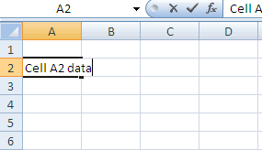
To enter data into the formula bar
- Click the cell where you would like the data
- Place the cursor in the Formula Bar
- Type in the data
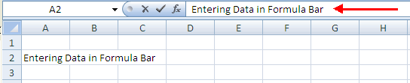

WHAT ARE SPREADSHEETS?

A spreadsheet is a group of cells organized into columns and rows containing data.
Cell References: Rows and Columns

A Row is a set of cells in the horizontal direction. Each row is numbered where the top-most row is numbered as 1. You can change the height of a row by moving your mouse over the row line and dragging it to your desired height.

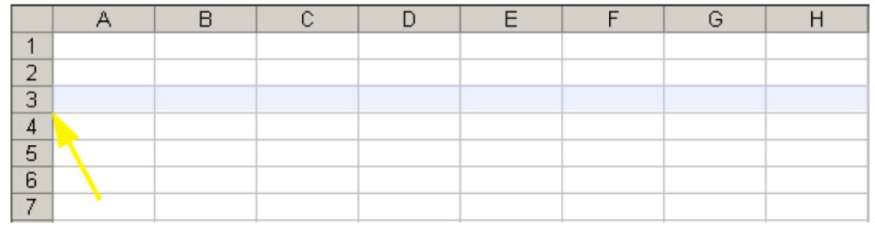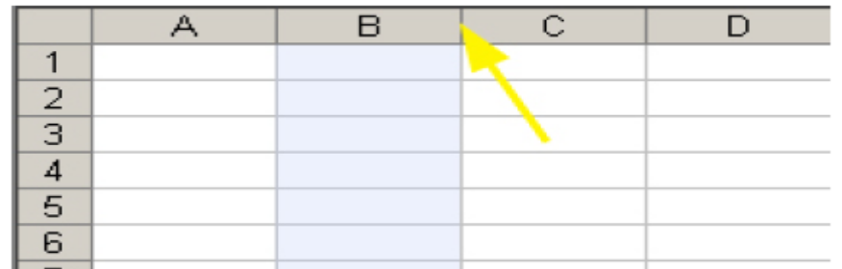

A Cell is a single box that is the intersection of a column and row. Each cell is named according to its column label and row number, called a Cell Reference.

For example, the highlighted cell shown below is named cell B3. The name box is located at the top left corner of the worksheet and displays the cell reference of the active cell.
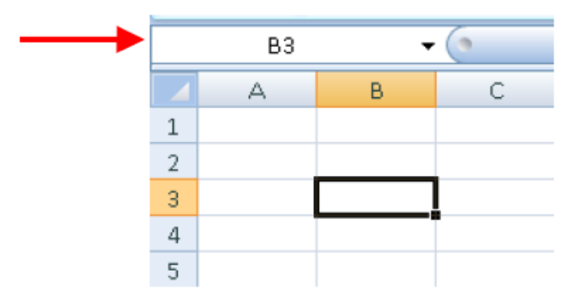

WORKING WITH DATA

You can enter text, numbers, Booleans, dates, times, and formulas into a cell.

TEXT

Text is any combination of numbers, spaces, and non-numeric characters. For example, Excel treats the following entries as text: 10AA109, 127AXY, 12-976, 208 4675. All text is left-aligned in a cell by default.

NUMBER

A number can contain only the following characters: 0 1 2 3 4 5 6 7 8 9 + - ( ) /. All numbers are right-aligned in a cell by default. Excel ignores leading plus signs (+) and treats a single period as a decimal. You can use the following characters to format the number: , $ %., e.g. 1,000, $13.25, and 57%. All other combinations of numbers and nonnumeric characters are treated as text.

BOOLEAN

The values TRUE and FALSE are special values called Boolean values. A Boolean expression in a formula will evaluate to one of these two values. Note that surrounding either TRUE or FALSE with quotes, e.g. “TRUE”, does NOT indicate a Boolean value, rather a text value.

DATE AND TIME

The way that a date or time is displayed on a worksheet depends on the format applied to the cell. All dates and times are right-aligned in a cell by default. A date may be a short date, e.g. 11/27/2008, or a long date, e.g. Thursday, November 27, 2008. Excel only recognizes dates staring from January 1, 1900. Also, Excel treats dates as numbers where 1/1/1900 is the same as 1, 1/2/1900 is the same as 2, and so on.
A time is formatted as hours, minutes, seconds, and AM/PM, e.g. 1:12:04 PM. Times are also numbers, where each time is a number between 0 and 1. For example, midnight is 0 and noon is 0.5, and 11:59:59 PM is 0.999988425925926. If Excel cannot recognize a date or time that you enter, then it is treated as text.

FORMULA

A formula is a mathematical expression that evaluates to a single value. It can be used to perform a useful calculation in a cell. You can construct a formula using any mix of the following components: constants, mathematical operators, cell references and ranges, and functions.

CONSTANTS

A constant is a number or text value that does not change.

MATHEMATICAL OPERATORS

A mathematical operator specifies a calculation. Common operators are: + (add), - (subtract), * (multiplication), and / (division).

CELL REFERENCES AND CELL RANGES

A cell reference in a formula evaluates to the value contained with that cell. A range of cells can be specified using the colon: symbol. A range can contain a row, a column, or a block of cells. As shown below, the syntax A1:C1, A1: A5, and B2:C5 specify ranges along a row, a column, and a block of cells, respectively.

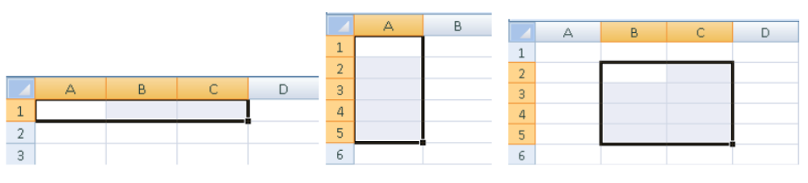

FUNCTIONS

A function is a pre-defined formula in Excel that you can insert into your formula. Each function is specified by its name and input arguments and evaluates to a single value.

CREATING FORMULAS

To create a basic formula, use the following procedure:
1) Select with your mouse the cell in which you would like to insert your formula, e.g. A1 in the figures below.
2) All formulas must start with an = sign.
3) After you type the = sign, type your syntactically correct formula.
4) Click Enter when you are done.

If you type your formula directly into the active cell then it will be simultaneously displayed in the Insert Function box. Alternatively, you may type your formula into the Insert Function box.

After you press Enter, the cell will display the evaluated value of your formula and the Insert Function box will display the formula
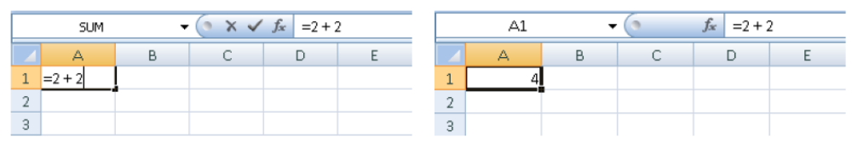

CALCULATING WITH FUNCTIONS

One or more functions may be specified in a formula to help calculate a desired final value in a cell. The most commonly used functions can be found under the AutoSum button, which looks like a summation symbol in mathematics and found on the Home tab under the Editing se.
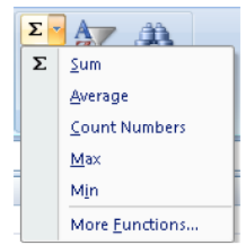
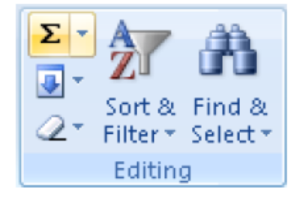

Consider the following table of student names and homework scores. The block of cells A1:D5 contain constant values (text and numbers).
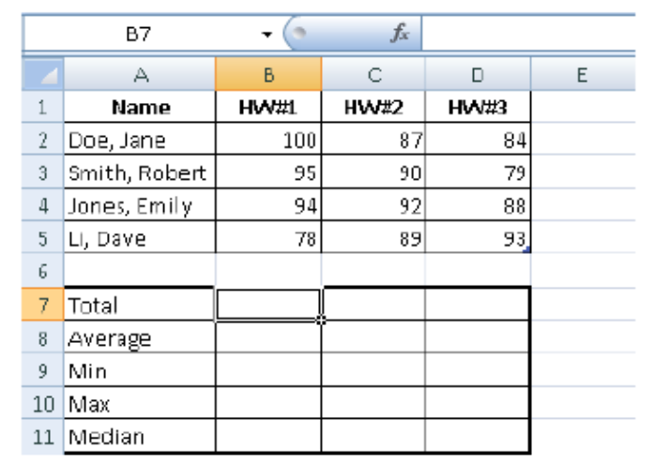

To compute the SUM over the column of HW#1 scores in cell B7 perform the following:

- Click on the cell B7 to make it the active cell.
- Click the AutoSum button’s drop-down menu and choose Sum.
- Highlight cells B2 through B5 with your mouse (Excel will outline the cells in the chosen range). The formula shown in cell B7 will be =SUM (B2:B5), where the function called SUM is given the range B2:B5 is its input argument.
- The cell B7 will display evaluated value (final answer) for the formula.

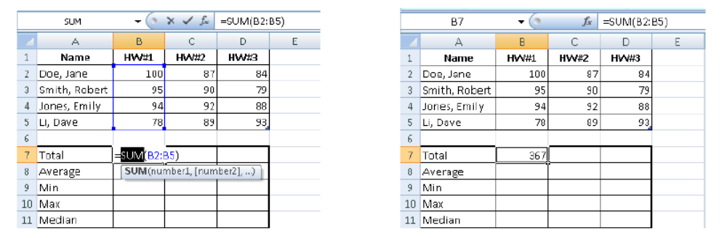

The AutoSum button contains other commonly used as listed below:

Sum: Add all the numeric values contained in the cells specified in the input argument. Average: Averages all the numeric values contained in the cells specified in the input argument.
Min: Determines the smallest numeric value among all the cells specified in the input argument.
Max: Determines the largest numeric value among all the cells specified in the input argument.
Count: Counts how many cells contain numeric values in the input argument.

The IF function

The IF function is a useful function in that it allows you to place one of two values in a cell based on a decision.

For example, if you would like to place either the text value “YES” or value “NO” in E2 based on the decision whether Jane Doe has the highest HW#1 score, then you can enter the formula:

=IF (B2 = B10, "YES", "NO")

The IF function has up to three comma separated arguments:

IF( <Boolean expression>, | A Boolean expression that evaluates to either TRUE or FALSE. You can use relational operators (<, >, =, <=, >=) and the Boolean functions AND, OR, and NOT to build your Boolean expression.
<Expression when TRUE>, | If the first argument evaluates to TRUE, then this expression is evaluated and the final value will display in the cell. This expression can evaluate to any value.
<Expression when FALSE>) | If the first argument evaluates to FALSE, then this expression is evaluated instead. This expression can also evaluate to any value. This argument is optional.

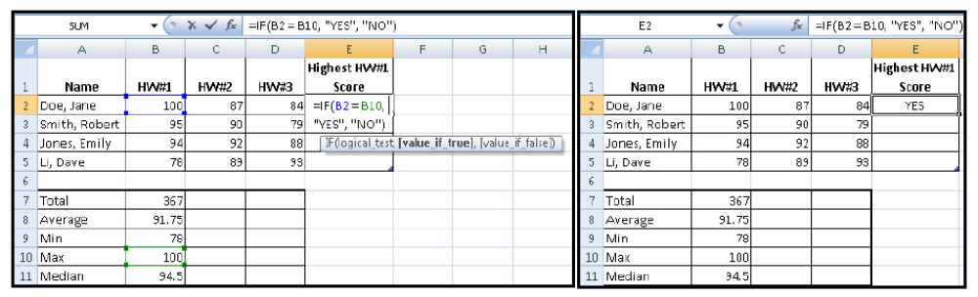

CUT , COPY & PASTE

You can copy (or cut) the contents of a cell and then paste the contents to a different cell.

- Select text which you want to copy by using mouse or key board (by shift and arrow keys)

  - Press CTRL+C (Depress the CTRL key while pressing the “C”) from the keyboard, for copy and CTRL+X for cut.

OR

  - You can select a shortcut button on ribbon a copy. Where you want to paste, you have to take cursor by using key board arrow keys Or by mouse click.

  - Press CTRL+V (Depress the CTRL key while pressing the “V”) from the keyboard, for paste the text. Which you already copy.

OR

  - You can select a shortcut button on ribbon as “Paste”.
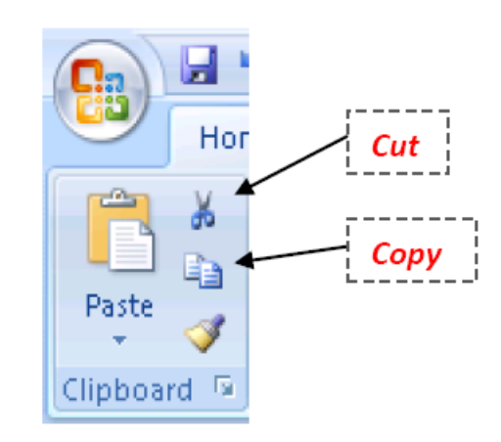

COPY/PASTE WITH AUTOFILL

To copy the contents of a cell to neighboring cells (along a row, column, or block of cells) use the AutoFill feature, which is the square located at the bottom right corner of the active cell.

For example:

To copy the number 22 in cell A1 (see left figure) to the cells in A2:A4, first click on the cell to activate it. Move your cursor over the AutoFill square so that your mouse pointer turns into a thin cross. Click down on the square with the left mouse button and drag your mouse to A4 Release you’re the left mouse button and you will see the result of the copy/paste in A2:A4.

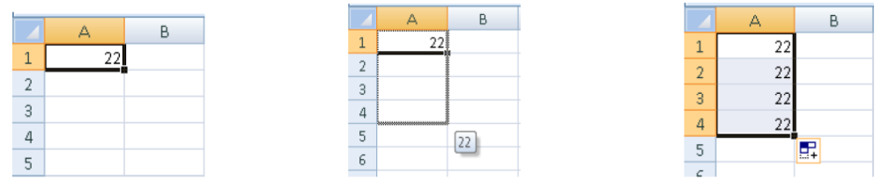

RELATIVE ADDRESSING

When you copy/paste formulas, Excel will preserve the structure of the formula but may change the cell references in the formula according to the direction in which the copy/paste occurs, called Relative Addressing.

For example,

If we copy the contents of cell B7 (=SUM (B2:B5)) and paste it across the row to cell D7l, then cell D7 will contain the updated formula =SUM(D2:D5), which is the total of all the HW#3 scores (see the left figure). Using the Auto fill feature again across each row, we can copy/paste the formulas at the bottom of the table to compute values for HW#2 and HW#3

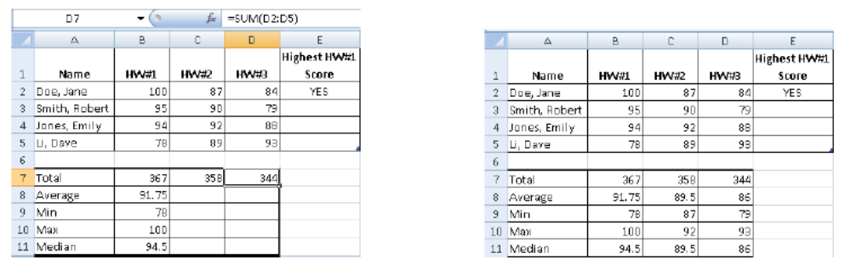

ABSOLUTE ADDRESSING

We can copy/paste the formula in cell E2 to down the column to E5 to determine whether or not each student has the highest HW#1 score. If copy/paste the formula

=IF (B2 = B10, "YES", "NO")

in cell E2 down the column, then the resulting formula in cell E5 will be

=IF (B5 = B13, "YES", "NO")

This formula is INCORRECT since we would like to compare the contents of cell B5 with the maximum over all HW#1 scores in cell B10.

The change of the cell reference change from B2 to B5 due to Relative Addressing is desired, but the change from B10 to B12 is not.

We can indicate that a cell reference in a formula must not change in a copy/paste by placing the $ symbol next to the row and column of the cell reference, called Absolute Addressing. Thus, the formula in cell E2 should be re-written as

=IF (B2 = $B$10, "YES", "NO")

After this formula is copy/paste down the column to cell E5, then cell E5 will contain the formula

=IF (B5 = $B$10, "YES", "NO")

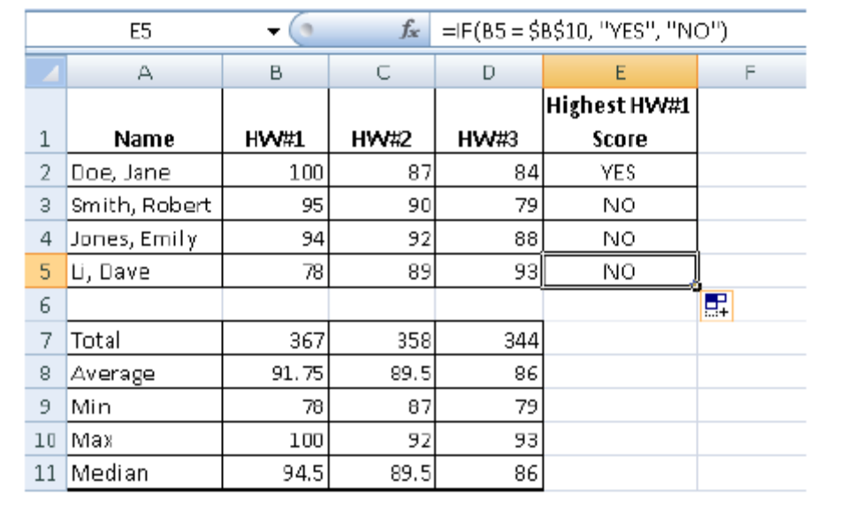

TEXT FORMATTING

Format text values using the commands in the Font Section such as the font type, font size, color, bold, italics, etc. Use the All Borders button to change the border attributes of blocks of cells.

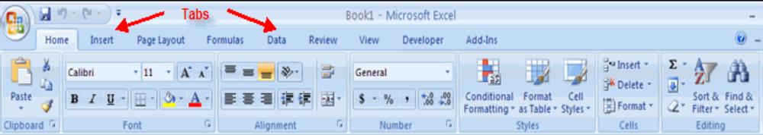
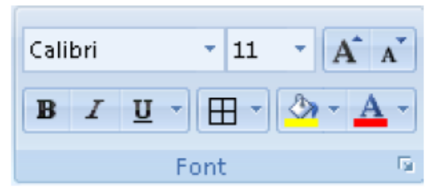

Position values in a cell both horizontally and vertically. If the text you type in a cell is longer than the width of the cell use the Wrap Text button to fit the text by adjusting the size and shape of the cell. If you would like to merge text in adjacent cells, then highlight all the cells and then press the Merge and Center button.
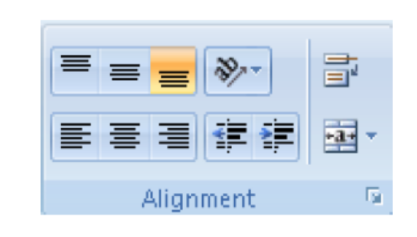

NUMBER FORMATTING

Format number values as you would like them to be displayed using the Number section. You can determine the number of digits to be displayed after the decimal place as well.
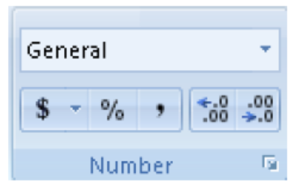

SORTING

Sort a table of data by first highlighting all the cells in the table (including any headings) and then select Sort & Filter from the Editing section and choose the order to sort the table. We sort the following table by Name in the following example.

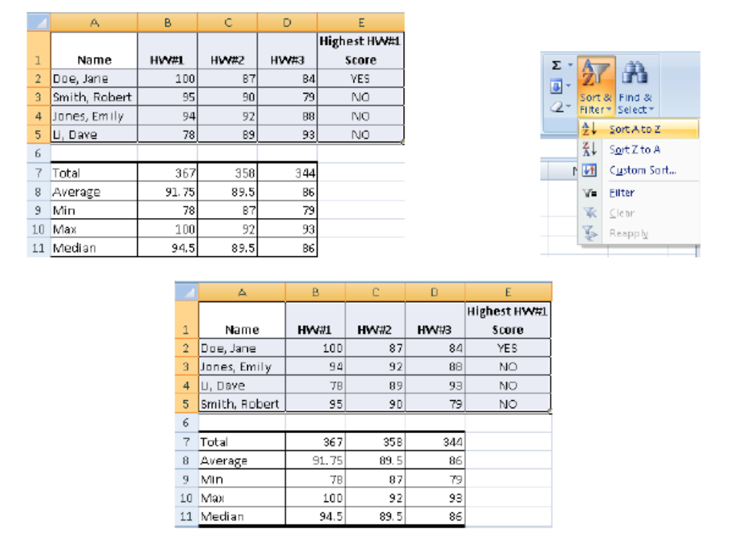

CELL FORMATTING

Excel provides pre-defined table formatting using the Styles section. Highlight your table of data and then use the Format as Table drop-down menu to choose a table format for the table heading and entries (see the top table, where the heading is colored black the data in blue). Change the look of groups of cells with the Cell Styles drop-down menu (see bottom table, where the cells are colored in light red).

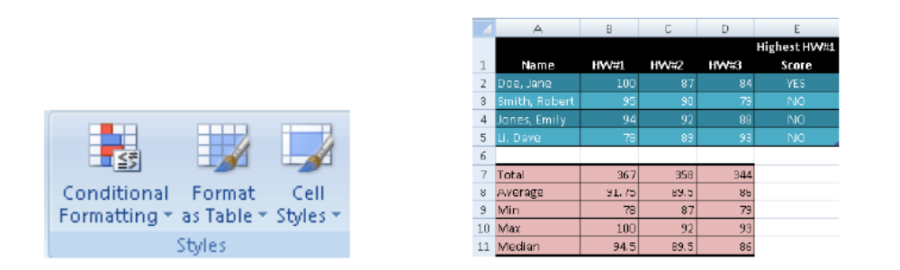

Insert or delete groups of cells or an entire row or column using the Cells section.
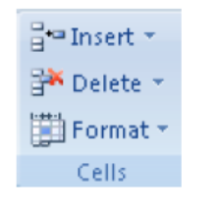

WHAT ARE CHARTS

Charts allow you to present information contained in the worksheet in a graphic format. Excel offers many types of charts including: Column, Line, Pie, Bar, Area, Scatter and more. To view the charts available click the Insert Tab on the Ribbon.
HOW TO CREATE A CHART
To create a chart:
- Select the cells that contain the data you want to use in the chart
- Click the Insert tab on the Ribbon
- Click the type of Chart you want to create
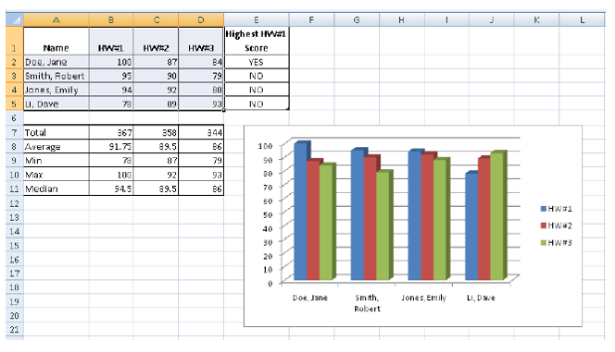

- Click the type of Chart you want to create
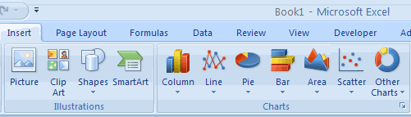
MODIFY A CHART
Once you have created a chart you can do several things to modify the chart.
To move the chart:
- Click the Chart and Drag it another location on the same worksheet, or
- Click the Move Chart button on the Design tab
- Choose the desired location (either a new sheet or a current sheet in the workbook)
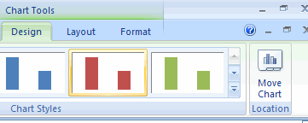
To change the data included in the chart:
- Click the Chart
- Click the Select Data button on the Design tab
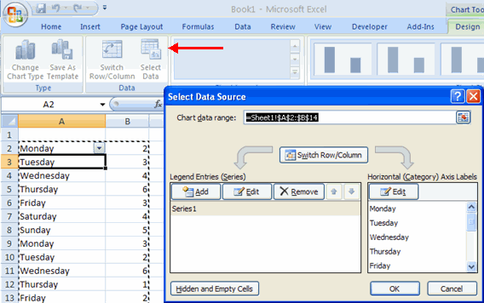
To reverse which data are displayed in the rows and columns:
- Click the Chart
- Click the Switch Row/Column button on the Design tab
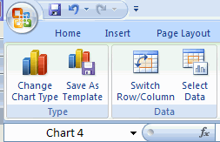
To modify the labels and titles:
- Click the Chart
- On the Layout tab, click the Chart Title or the Data Labels button
- Change the Title and click Enter
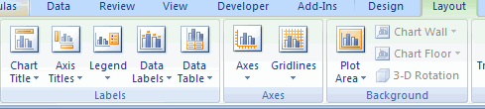

CHART TOOLS
The Chart Tools appear on the Ribbon when you click on the chart. The tools are located on three tabs: Design, Layout, and Format.
Within the Design tab you can control the chart type, layout, styles, and location.
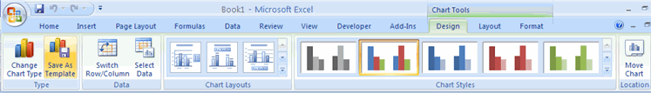
Within the Layout tab you can control inserting pictures, shapes and text boxes, labels, axes, background, and analysis.
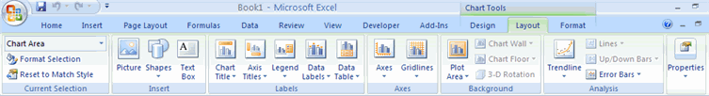
Within the Format tab you can modify shape styles, word styles and size of the chart.
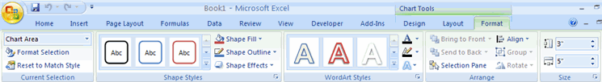
COPY A CHART TO WORD
- Select the chart
- Click Copy on the Home tab
- Go to the Word document where you want the chart located
- Click Paste on the Home tab
